

Group Assessment Coversheet

To be attached to the front of the assessment.

**Campus: Pretoria and Bedfordview**

**Faculty: Information Technology**

**Module Code: ITEHA3-B33**

**Group: 2**

**Lecturer’s Name:** **Ms. Magongo. N.**

|  |  |  |
| --- | --- | --- |
| **Indicate** | **Yes** | **No** |
| Plagiarism report attached |  |  |

**Declaration:**

I declare that this assessment is my own original work except for source material explicitly acknowledged. I also declare that this assessment or any other of my original work related to it has not been previously, or is not being simultaneously, submitted for this or any other course. I also acknowledge that I am aware of the Institution’s policy and regulations on honesty in academic work as set out in the Eduvos Conditions of Enrolment, and of the disciplinary guidelines applicable to breaches of such policy and regulations.

Eduvos (Pty) Ltd. (formerly Pearson Institute of Higher Education) is registered with the Department of Higher Education and institution under the Higher Education Act, 101, of 1997. Registration Certificate number: 2001/HE07/008Training as a private higher education

|  |  |  |  |
| --- | --- | --- | --- |
|  | |  | **% Participated** |
| **1** | **Student Full Name** | **Lea Thumbiran** | **50%** |
| **Student Number** | **LMTPQFTH6** |
| **Contact Number** | **079 898 2004** |
| **Signature** |  |
| **2** | **Student Full Name** | **Arno Moller** | **50%** |
| **Student Number** | **CC96ZRRS5** |
| **Contact Number** | **071 641 1562** |
| **Signature** |  |

**Lecturer’s Comments:**

|  |  |  |  |
| --- | --- | --- | --- |
| **Marks Awarded:** |  |  | **%** |

|  |  |
| --- | --- |
| **Signature** | **Date** |

Group Assignment Coversheet 2021 | V1.1 Page 2 of 2

**Eduvos**

**Enterprise Programming in C#**

**(ITEHA3-B33)**

**Group Assignment**

**Ms. Magongo. N**

**Lea Thumbiran LMTPQFTH6**

**Arno Moller CC96ZRRS5**

**8 August 2023**

Table of Contents

1.1 Introduction: 1

1.2 GitHub Repository for the Chatting Application: 2

1.3 User Flow Diagram for the Chatting Application: 3

1.4 System Architecture Diagram for the Chatting Application: 5

1.5 Selected Design Pattern for the Chatting Application - MVVM 7

1.6 Features of the Chatting Application: 9

1.7 Screenshots of the Chatting Application: 10

1.8 Possible Improvements for the Chatting Application 20

1.9 Conclusion: 21

Bibliography 22

# Introduction:

The objective of this assignment is to cultivate a comprehensive grasp of enterprise architectural frameworks and design patterns, while also gaining proficiency in developing distributed applications and utilizing modern source control repositories like Git and GitHub. As a practical application of these concepts, the assignment entails creating a chat application using C# that serves as a model for understanding service-oriented architecture.

# 1.2 GitHub Repository for the Chatting Application:

The GitHub repository can be found here: <https://github.com/leathumbiran02/ChattingApplication>

# 1.3 User Flow Diagram for the Chatting Application:

The user flow diagram showing the login, registration, connecting to the chatting application, sending messages, and disconnecting from the chatting application is shown below:

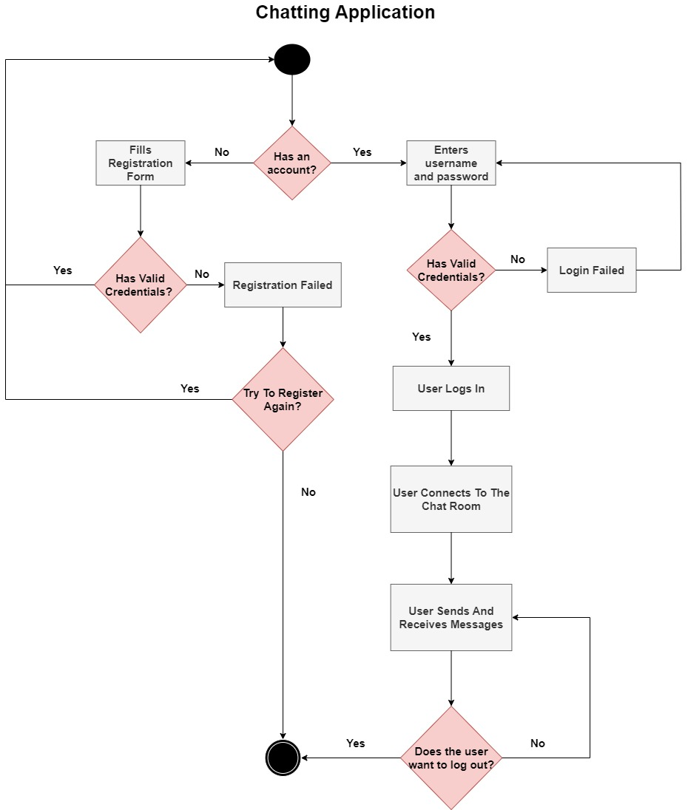

Figure 1 – User flow diagram of a chatting application and its processes (Ivonna, 2022).

The diagram above does the following:

* By default, the chatting application displays the registration page, here users will have the option to register for an account by filling out their account details. If their details are valid then they are redirected to the login page and can then log in with their account details. If their account details are invalid (such as their email address does not exist or their password and confirm password do not match) the registration will fail, the user can then try to register again or close the chatting application.
* If the user does have an account, then they can enter their username and password, if their details are valid, then they can log in, connect to the Chat Room, and send and receive messages on the chatting application. If their details are invalid, the login will fail, the user can then try to log in again.
* While the user is connected to the Chat Room, they have the option to log out, if they log out the Chatting Application will disconnect them from the Chat Room and end the process.
* If the user does not log out, they can continue to send and receive messages in the Chat Room.

# 1.4 System Architecture Diagram for the Chatting Application:

The system architecture diagram for the chatting application is shown below:

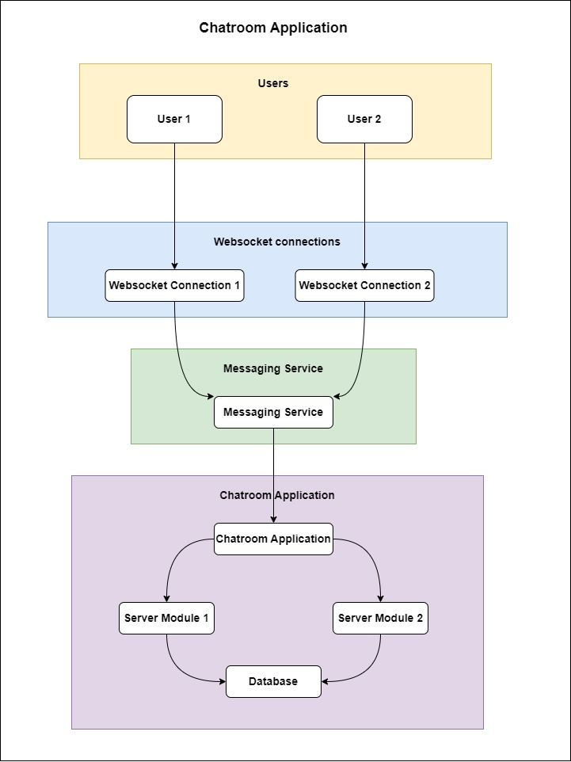

Figure 2 - System architecture diagram of a chatting application (Pareek, 2023).

The diagram above does the following:

* Once the user successfully logs in, they will proceed to establish a connection to the web sockets.
* Once this connection is established, they will gain access to the messaging service, enabling them to connect to the chatroom application.
* This chatroom application is designed to interface with their separate server modules, which in turn establish connections to the respective databases.
* This architecture allows for a structured and compartmentalized approach to handling user interactions and data storage.

# 1.5 Selected Design Pattern for the Chatting Application - MVVM

**Model-View-ViewModel (MVVM)** is a software architectural pattern used in the creation of user interfaces, especially in applications that use graphical user interfaces (GUIs) (Gallardo, 2023).

**The MVVM design pattern consists of the following:**

* ***Model:*** The model represents the data and business logic of the application (Microsoft, 2022). It contains the data and processes that are not dependent on the user interface (Microsoft, 2022). Database operations, calculations, data retrieval, and other tasks fall under this category (Microsoft, 2022). The model is oblivious to the user interface and is unconcerned about how the data is presented or modified (Microsoft, 2022).
* ***View:*** The view is responsible for displaying data to the user and capturing user input (Microsoft, 2022). It represents user interface elements which include buttons, labels, textboxes, and other graphic elements (Microsoft, 2022). In contrast to typical MVC (Model-View-Controller) architectures, the view in MVVM includes very little logic (Microsoft, 2022). It only handles basic input validation and formatting, letting the ViewModel handle more advanced logic (Microsoft, 2022).
* ***ViewModel:*** The ViewModel works as a go-between for the Model and the View (Microsoft, 2022). The ViewModel includes presentation logic as well as data transformation code (Microsoft, 2022). It prepares and organises the data so that it may be displayed in the View (Microsoft, 2022). Furthermore, the ViewModel can expose commands to which the View can attach to handle user activities (Microsoft, 2022). It acts as a conduit for data from the Model to the View and for user interactions from the View to the Model (Microsoft, 2022).

**Key features in the MVVM design pattern** (Microsoft, 2022)**:**

* **Data Binding:** MVVM is strongly reliant on data binding protocols, which ensure that changes in the ViewModel are automatically reflected in the View, and vice versa.
* **Commanding prompts:** The ViewModel exposes instructions that can be attached to UI elements such as buttons and textboxes. These commands are run in response to UI events and encapsulate user activities.
* **Testability:** MVVM's separation of concerns makes unit testing of each component (Model, ViewModel, and View) easier.
* **Flexibility:** Any changes to the UI layout or behaviour can be handled frequently without affecting the underlying business logic, as a result, MVVM enables more flexible UI design and development.

MVVM provides advantages such as enhanced code organization, testability, reusability, and flexibility (Ramotion, 2023). Due to these benefits, as well as its interoperability with modern UI frameworks, MVVM is a popular architectural paradigm for creating applications with rich graphical user interfaces and therefore is an ideal method for creating a chat application (Ramotion, 2023).

# 1.6 Features of the Chatting Application:

The chatting application, developed with the **MVVM (Model-View-ViewModel)** design pattern, encompasses a comprehensive set of functionalities which include:

* The creation of accounts.
* Secure log-in.
* Real-time conversations between users through an intuitive chat box interface.
* Log out functionalities.
* Logging of a user’s conversation history in a text file.
* Logging of run-time errors and exceptions with the Client and Server in their respective text files.

The selected design pattern (MVVM) ensures that there is a clear separation of concerns.

The **Model** component efficiently manages user account data, and chat messages, and orchestrates communication with the server.

The **View** component is responsible for rendering the user interface elements, encompassing features like the login and sign-up screens and the interactive chat interface.

Bridging the gap between these elements, the **ViewModel** plays a pivotal role by mediating data binding, exposing methods, and presenting properties that enable smooth interaction between the **View** and the underlying **Model**.

Ultimately, the **MVVM**-driven approach harmonizes the creation of accounts, authentication, chatting, and server communication into a cohesive and user-friendly experience.

# 1.7 Screenshots of the Chatting Application:

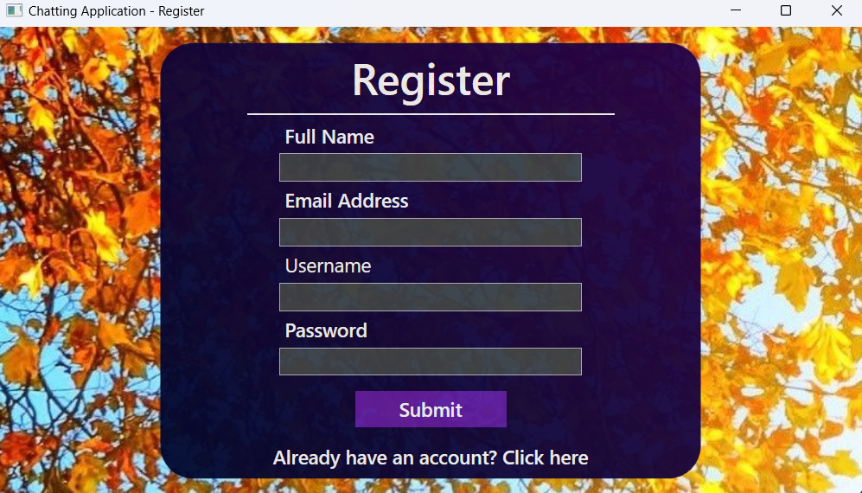

Figure 3 - The registration page when a user opens the Chatting Application for the first time.

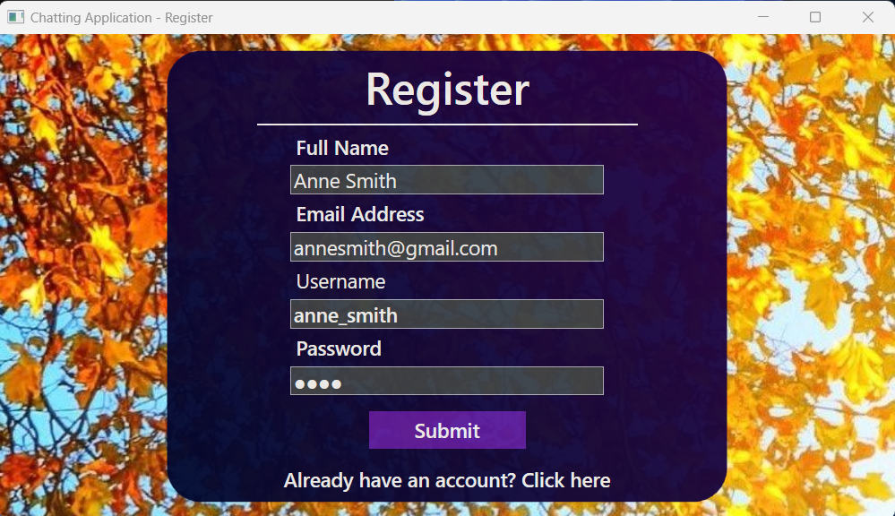

Figure 4 - A user creating an account.

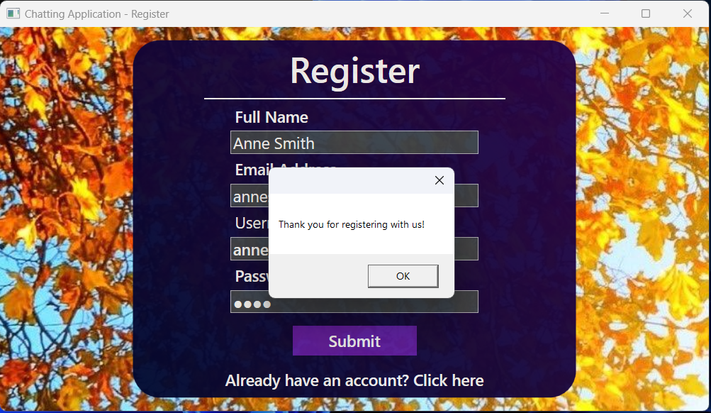

Figure 5 - A notification informing the user that their account has been created.

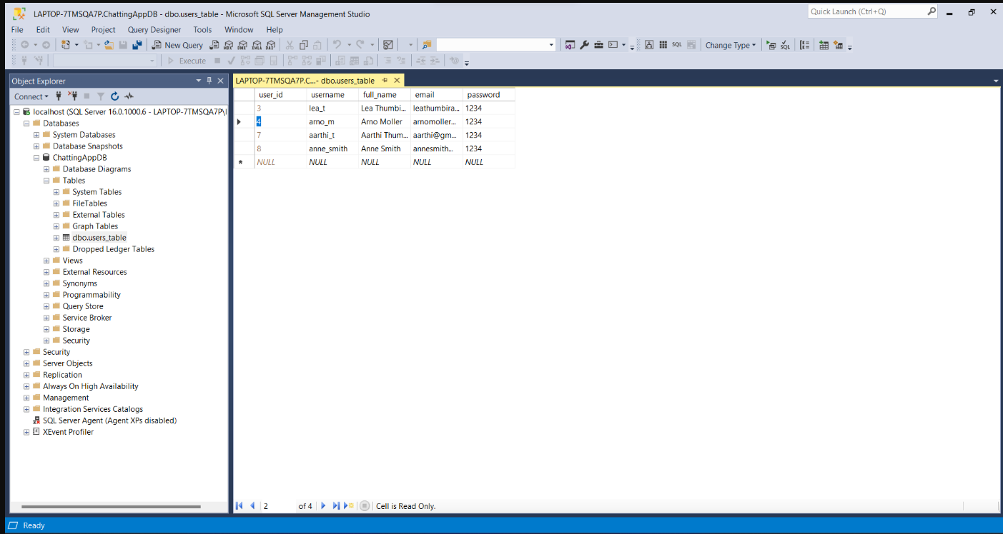

Figure 6 - Showing that the user's account details have been saved in the SQL Server database.

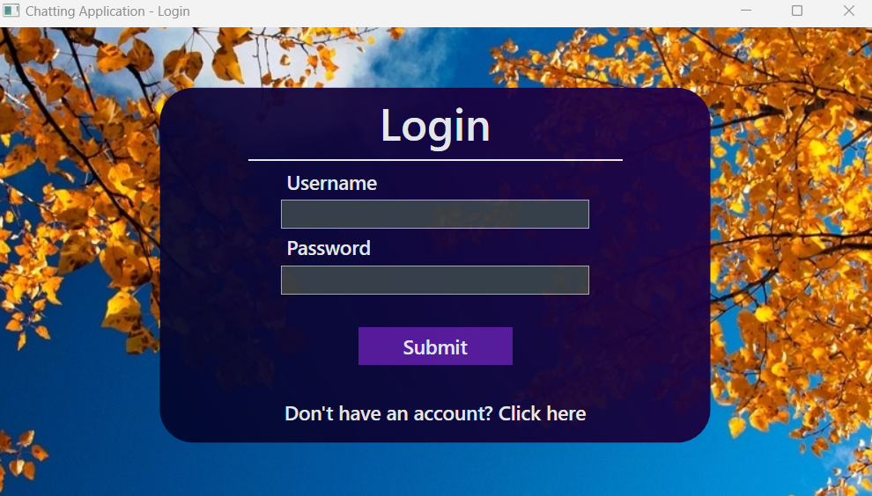

Figure 7 - After a user creates an account, they are then directed to the login page.

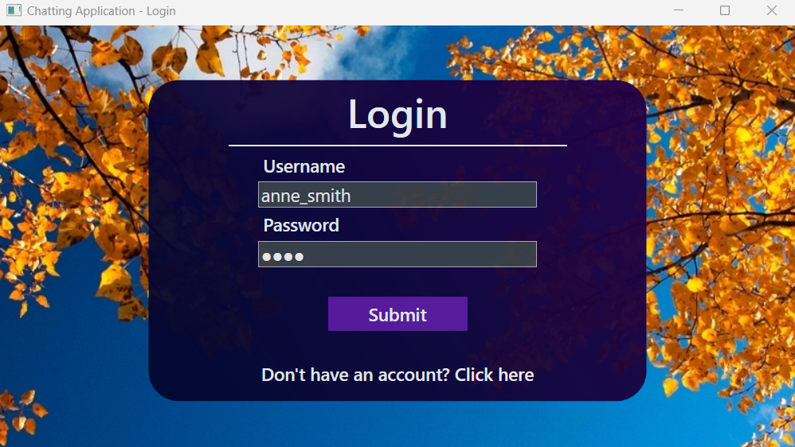

Figure 8 - A user logging into the Chatting Application using their account details.

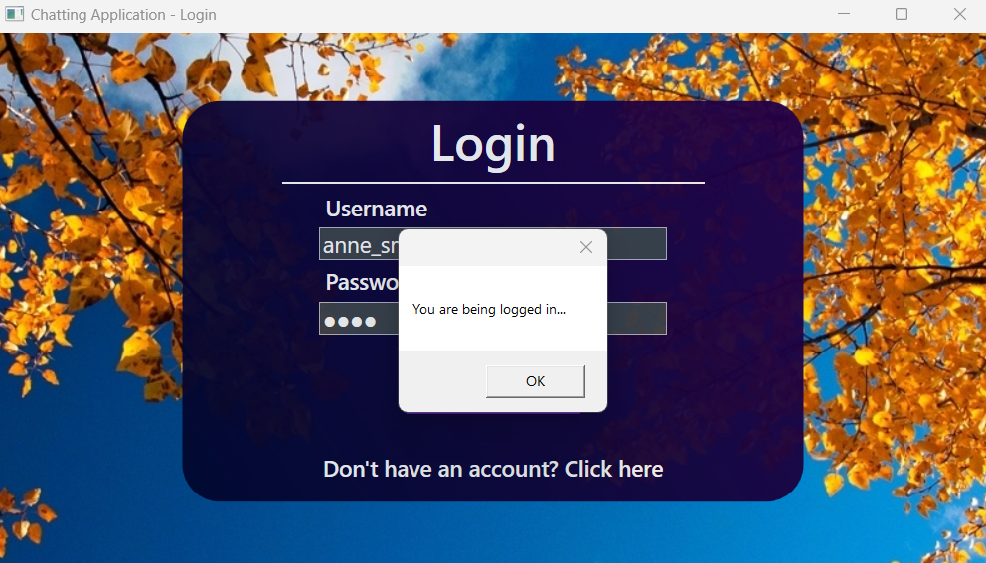

Figure 9 - A notification informing the user that they are being logged in.

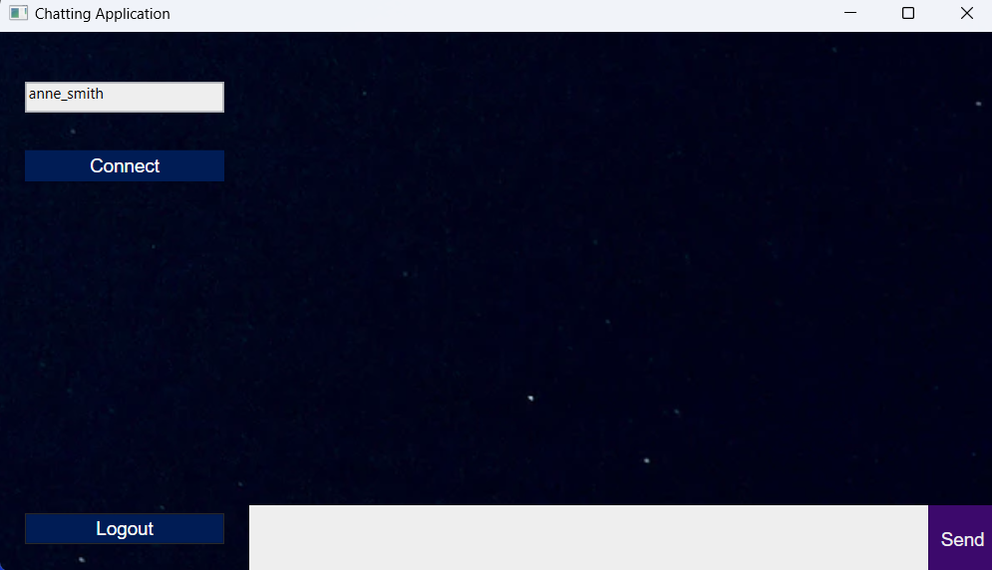

Figure 10 - After logging in, the user is directed to the Chat Room. Their username is filled out for them in the top left text box.

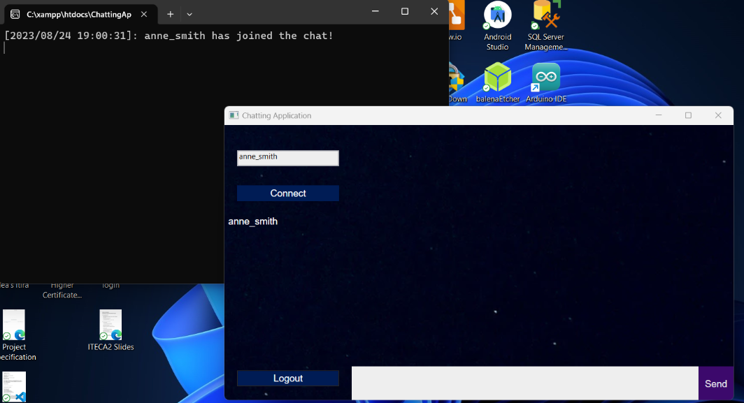

Figure 11 - The user clicks the Connect button to connect to the Chat Room. A message saying that the user has connected to the chat room is sent to the Server console as seen on the top left of the screen.

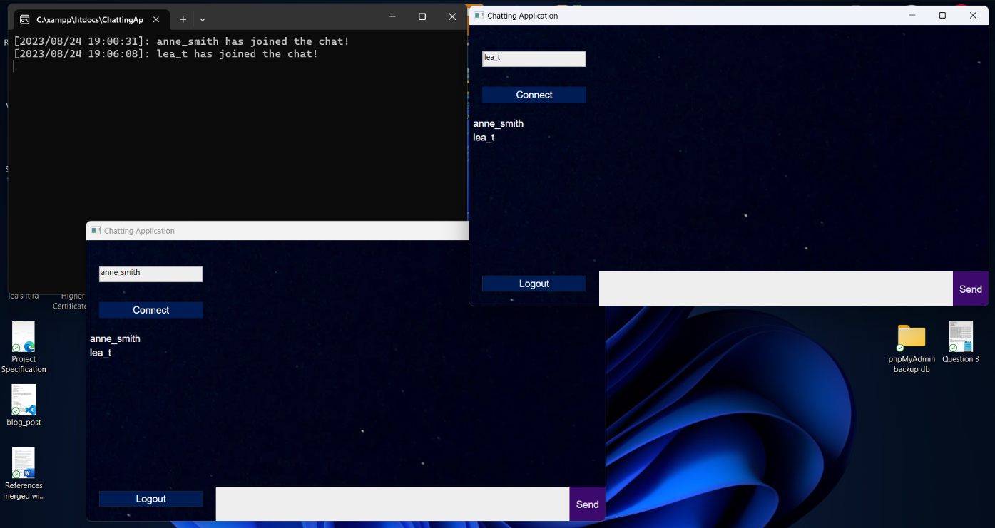

Figure 12 - Connecting another user to the Chat Room. There is a list of users in each Chat Room that gets updated each time a new user joins the Chat Room.

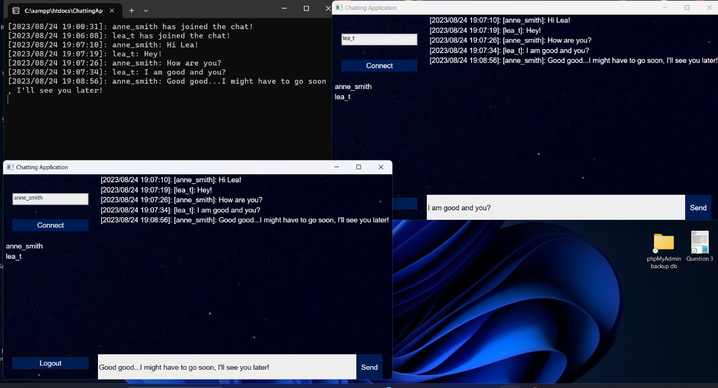

Figure 13 - Sending messages between two users. Their messages are sent to the Chat Room and the Server console and are timestamped.

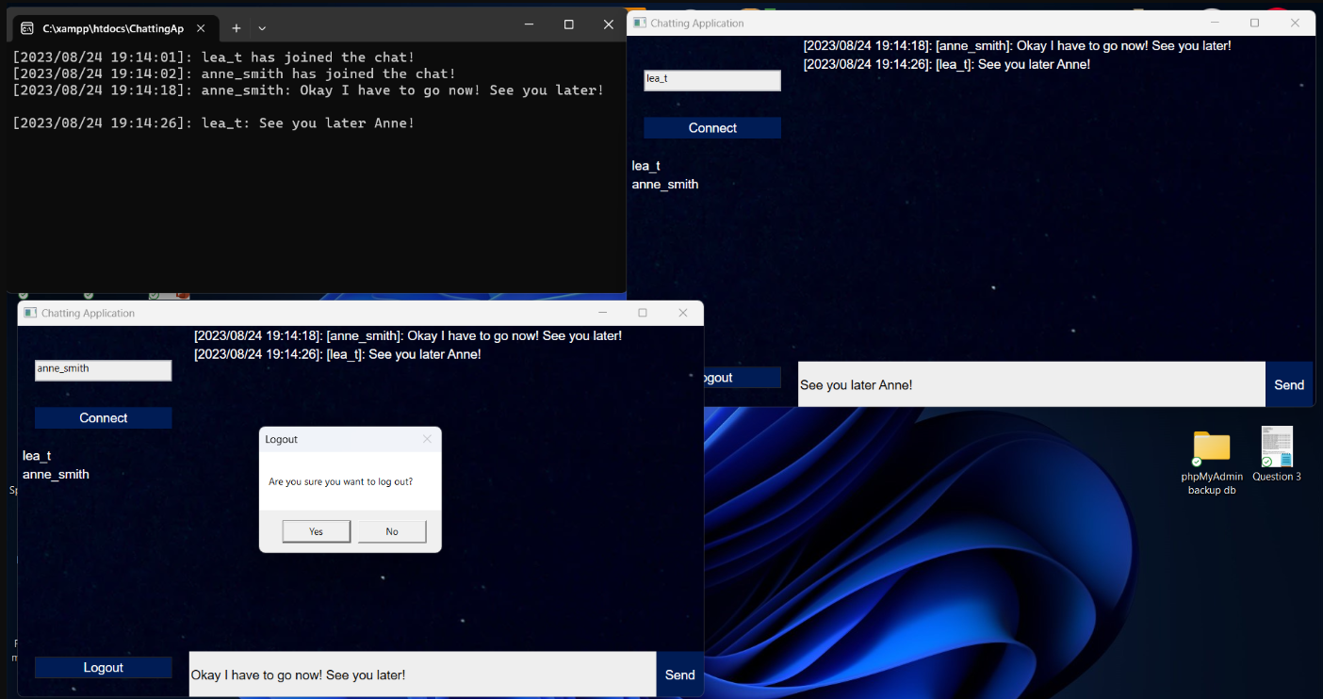

Figure 14 - A user logging out and leaving the Chat Room.

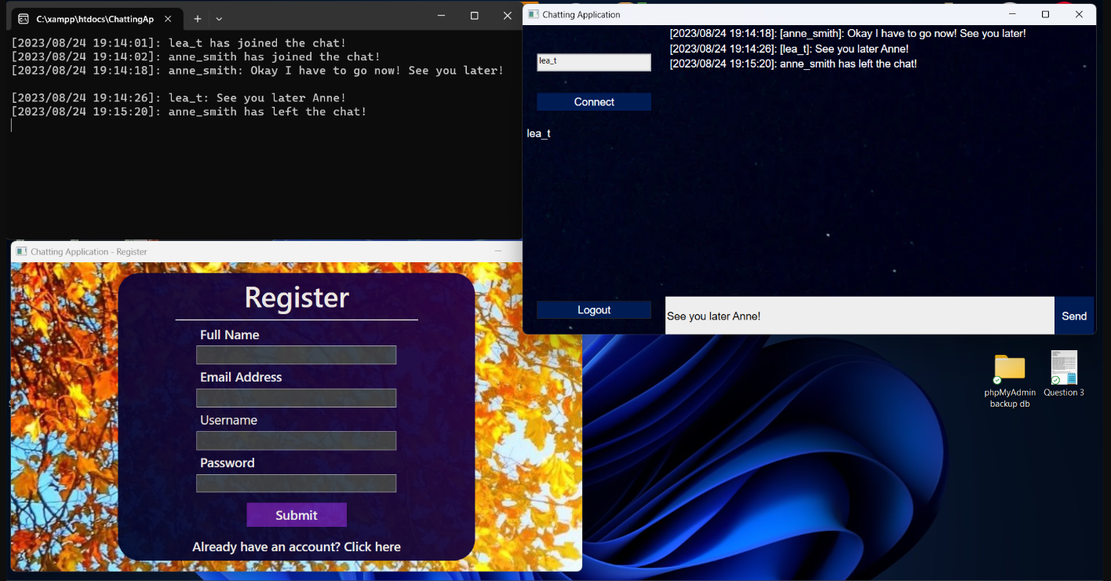

Figure 15 - Once a user has logged out of the Chatting Application, they are directed to the Registration page. All other users in the Chat Room are notified of the time at which the user has left. The same message is sent to the Server console.

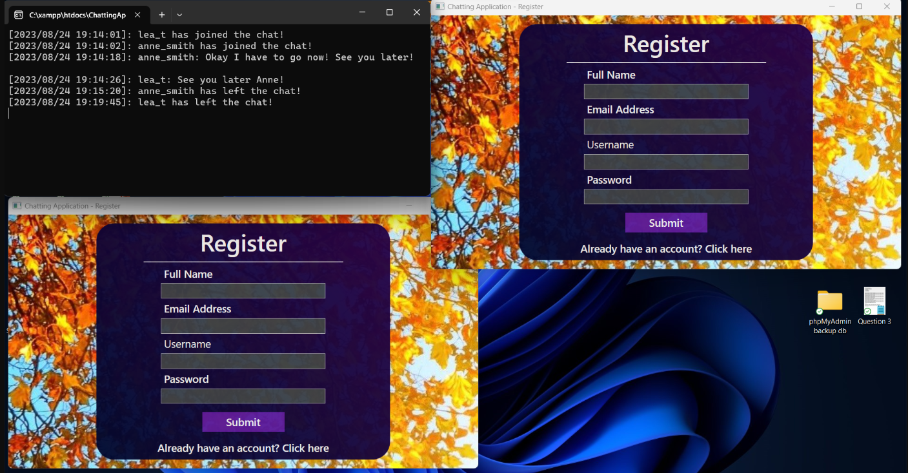

Figure 16 - Logged out all users from the Chat Room.

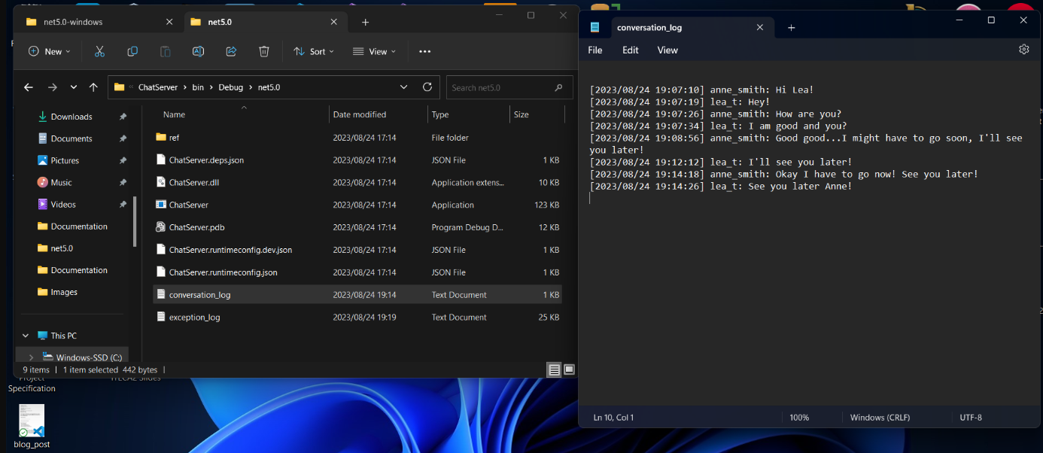

Figure 17 - A text file named conversation_log.txt that logs the conversation history between users in the Chat Room.

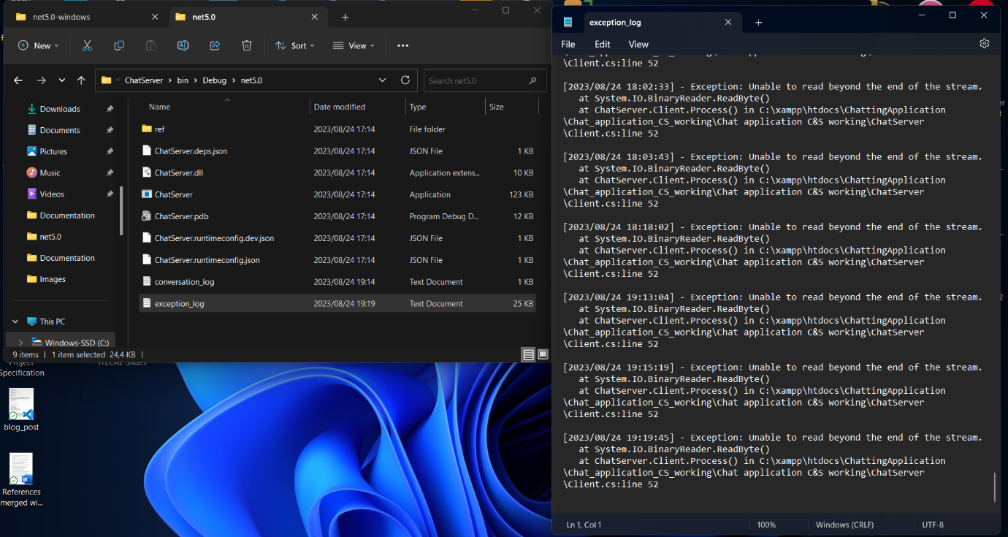

Figure 18 - A text file named exception_log.txt that logs runtime errors and exceptions in the Client.

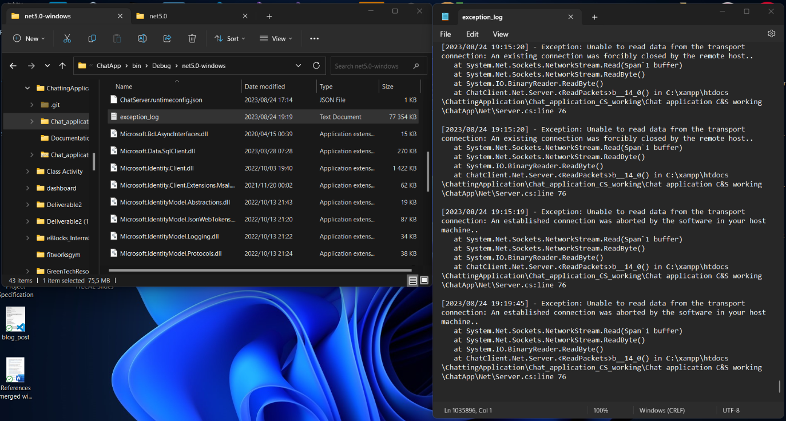

Figure 19 - A text file named exception_log.txt that logs runtime errors and exceptions in the Server.

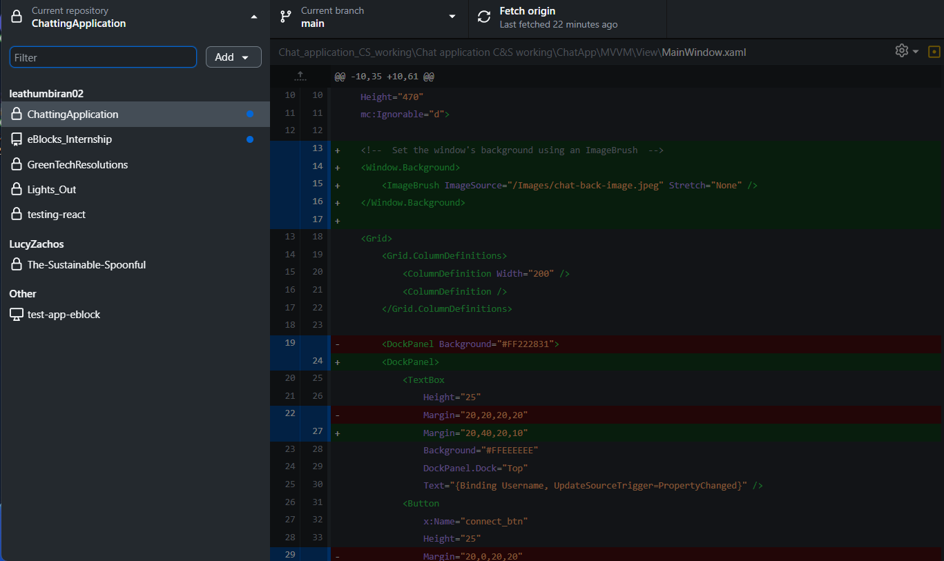

Figure 20 - Showing the GitHub repository for the Chatting Application on GitHub Desktop.

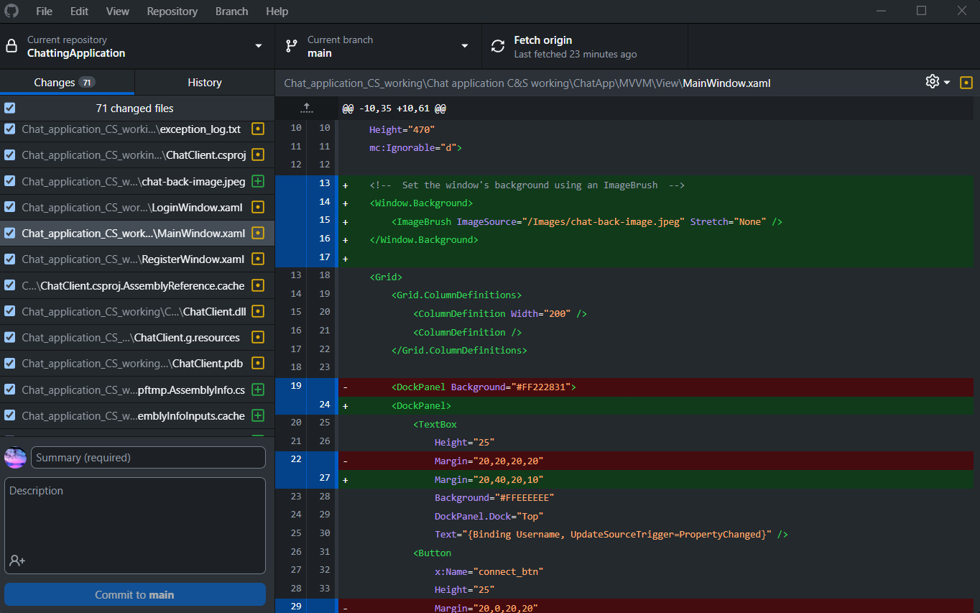

Figure 21 - Showing the GitHub repository for the Chatting Application on GitHub Desktop.

# 1.8 Possible Improvements for the Chatting Application

If the Chatting Application were to be updated in the future, the following features could be added:

* Edit user account details.
* Delete user accounts.
* Create and manage Chat Rooms.
* Send images and videos in Chat Rooms.
* Edit and retract Messages that have been sent in Chat Rooms.
* Customise user profiles.

These features would further enhance the experience of users who use this Chatting Application.

# 1.9 Conclusion:

The usage of the MVVM design in the creation of our chat application is a huge step forward in producing a robust, user-friendly, and scalable communication platform. We were able to compartmentalize our coding thanks to the MVVM (Model-View-ViewModel) design, which promotes modularity and maintainability throughout the development process. By implementing an agile approach in creating this application, we could use the best design principles, code organization, and give the best user experience.

# Bibliography

Chaurasia, R., 2017. *How to create Login and Register page with Database connection in asp.net C# 5.0.* [Online]   
Available at: https://youtu.be/x6hZaxdiqbI?si=zU8BrfNri1cyXmwH[Accessed 15 August 2023].

CodAffection, 2017. *How to Create Login Screen in Wpf with Sql DataBase.* [Online]   
Available at: https://youtu.be/72366X1-heg?si=CNjzfXPnFzYyuwc0[Accessed 14 August 2023].

CODE PROJECT, 2013. *What is the difference between System.Data.SqlClient and System.Data.Common - CodeProject.* [Online] Available at: https://www.codeproject.com/questions/577809/whatplusisplustheplusdifferenceplusbetweenplussyst[Accessed 15 August 2023].

denden, 2021. *WPF Login and Register Page using SQL Server.* [Online]   
Available at: https://youtu.be/7mD_QdO1WZg?si=Jm4j-KMU7SpiS4kR  
[Accessed 15 August 2023].

edrawsoft, 2023. *System Architecture Diagram: A Complete Tutorial.* [Online]   
Available at: https://www.edrawsoft.com/article/system-architecture-diagram.html  
[Accessed 13 August 2023].

FreeCodeCamp, 2020. *ASP.NET Core Crash Course - C# App in One Hour.* [Online]   
Available at: https://www.youtube.com/watch?embed=no&v=BfEjDD8mWYg  
[Accessed 19 August 2023].

Gallardo, E. G., 2023. *What Is MVVM Architecture?.* [Online]   
Available at: https://builtin.com/software-engineering-perspectives/mvvm-architecture  
[Accessed 12 August 2023].

Gavin, J., 2022. *SSMS Download, Install and Configure.* [Online]   
Available at: https://www.mssqltips.com/sqlservertip/7156/ssms-download-install-configure/  
[Accessed 15 August 2023].

InterviewBit, 2023. *System Architecture – Detailed Explanation.* [Online]   
Available at: https://www.interviewbit.com/blog/system-architecture/  
[Accessed 13 August 2023].

Ivonna, C., 2022. *What is a User Flow Diagram and How to Create One?.* [Online]   
Available at: https://venngage.com/blog/user-flow-diagram/[Accessed 13 August 2023].

Kindson The Tech Pro, 2020. *How to Create a new Login in Microsoft SQL Server 2019.* [Online]   
Available at: https://youtu.be/qfuK0V1tlrA?si=oTskpg23FsM9fNEZ[Accessed 17 August 2023].

Microsoft, 2022. *.NET Framework development guide.* [Online]   
Available at: https://learn.microsoft.com/en-us/dotnet/framework/development-guide[Accessed 20 August 2023].

Microsoft, 2022. *Model-View-ViewModel (MVVM).* [Online]   
Available at: https://learn.microsoft.com/en-us/dotnet/architecture/maui/mvvm  
[Accessed 12 August 2023].

Microsoft, 2023. *Download SQL Server Management Studio (SSMS) - SQL Server Management Studio (SSMS).* [Online] Available at: https://learn.microsoft.com/en-us/sql/ssms/download-sql-server-management-studio-ssms?view=sql-server-ver16#download-ssms  
[Accessed 15 August 2023].

Microsoft, 2023. *Introduction to Microsoft.Data.SqlClient namespace - ADO.NET Provider for SQL Server.* [Online] Available at: https://learn.microsoft.com/en-us/sql/connect/ado-net/introduction-microsoft-data-sqlclient-namespace?view=sql-server-ver16  
[Accessed 15 August 2023].

Microsoft, 2023. *System.Data.SqlClient 4.8.5.* [Online] Available at: https://www.nuget.org/packages/System.Data.SqlClient[Accessed 19 August 2023].

ParallelCodes, 2018. *WPF Create Login Form with SQL Database.* [Online]   
Available at: https://youtu.be/oQmM0698Eeo?si=DEi2AwJ0mO0utB5t  
[Accessed 15 August 2023].

Pareek, K., 2023. *Architecture of a System.* [Online]   
Available at: https://www.geeksforgeeks.org/architecture-of-a-system/  
[Accessed 13 August 2023].

Payload, 2021. *How To Create a Chat App and Server Tutorial WPF C#.* [Online]   
Available at: https://youtu.be/I-Xmp-mulz4?si=Q8gFXkfXwOjrsmn1  
[Accessed 15 August 2023].

Price, M. J., 2019. *C# 8.0 and .NET Core 3.0 - modern cross-platform development : build applications with C#, .NET Core, Entity Framework Core, ASP.NET Core, and ML.NET using Visual Studio Code.* Birmingham: Packt Publishing Ltd.

Ramotion, 2023. *Understanding MVVM: Model-View-ViewModel Architecture Explained.* [Online]   
Available at: https://www.ramotion.com/blog/what-is-mvvm/[Accessed 12 August 2023].

RJ Code Advance EN, 2022. *Create Login in WPF, MVVM Pattern, C# and SQL Server - Step by Step + Display user data.* [Online] Available at: https://youtu.be/FGqj4q09NtA?si=kc4tgbXND4MLjzHF[Accessed 15 August 2023].

Senthilvel, G., Khan, A. & Qureshi, H. A., 2017. *Enterprise Application Architecture with .NET Core.* s.l.:Packt Publishing Ltd.

Tutorials, D. N., 2023. *Download and Install SSMS.* [Online]   
Available at: https://dotnettutorials.net/lesson/download-and-install-ssms/[Accessed 10 August 2023].